#1 - Pauite Shelter
www.zimbio.com
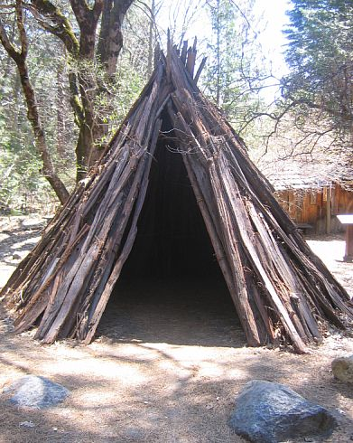
The Yosemite Miwuk Native village located in Yosemite National Park that is really based on Yosemite Paiute Native American camp.

#2 - Pauite Indians
historytogo.utah.gov/utah_chapters/american_indians
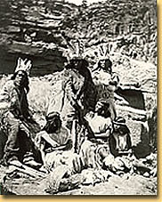
Picture of Paiute Indians in traditional wear.

#3 - Pauite Family
www.legendsofamerica.com

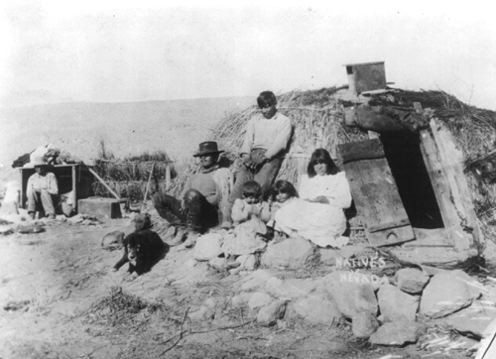
Photo of a Pauite family. As a people the Pauite were peaceful and industrious.

#4 - www.applevalley.org

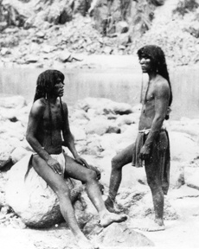

#5 - www.powwows.com

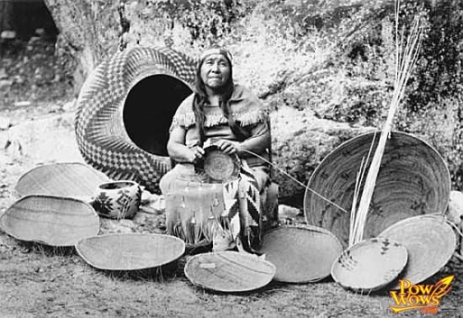

#6 - flicker.com/photos

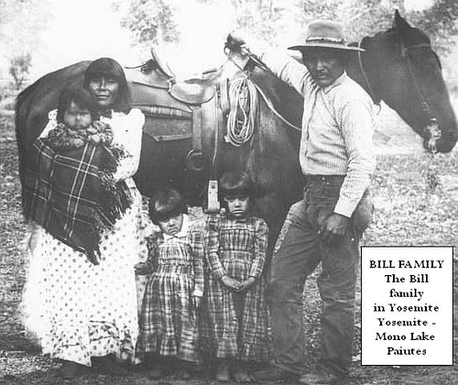

#7 - www.nps.gov/cebr/historyculture/images/Paiutes

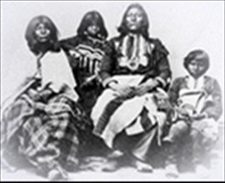

#8 - www.everyculture.com

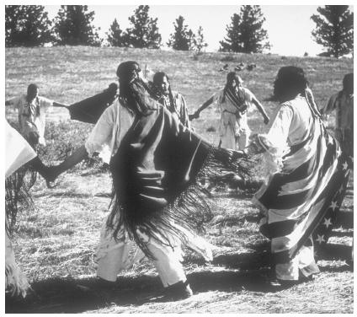

The traditional ghost dance.

#9 - http://thehive.modbee.com

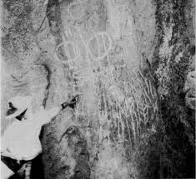
#10 - www.utahpaiutes.org
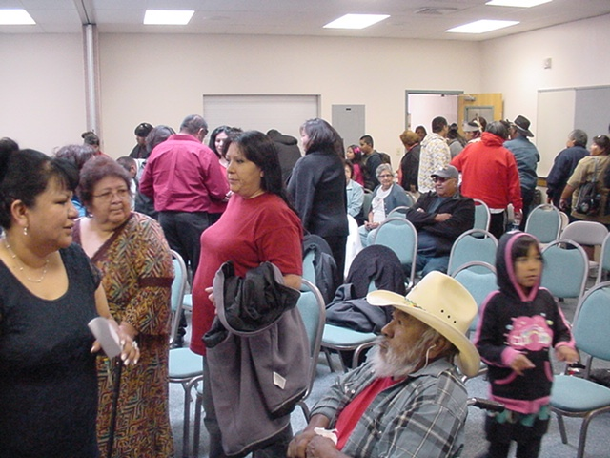

A community meeting today.

#11 - Pauite Basketry
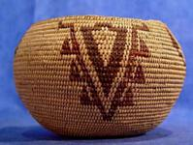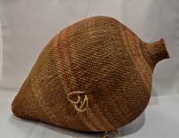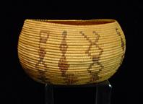

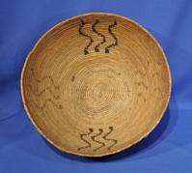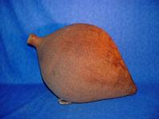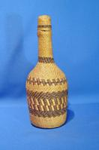

http://www.navajorugsindianbaskets.com/html/artistresults.asp?artist=455&testing=true

#12 - Artifacts
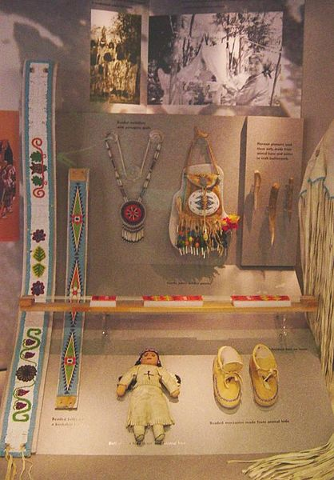
http://en.wikipedia.org/wiki/File:Southern_Paiute_artifacts.jpeg

